REGRESSION TEST PROCESS

Contents

1 INTRODUCTION 2

2 PROCESS 2

3. PROCEDURE 2

3.1. Test Plan 2

3.1.1. Monthly regression test 2

3.1.2. Maintenance regression test 3

3.2. Test implementation 4

3.3 Test execution 5

3.4 Defect management 7

3.4.1. General 7

3.4.2. Rules for tracking WW defect happened in multiple countries 7

3.4.3. Duplicated rule. 8

3.4.4. Reject rule 9

3.5. Defect analysis and Lesson learnt. 9

# 1 INTRODUCTION

Plan, design and conduct test software products to assure that

- Requirements have been fulfilled

- Defects have been detected and resolved before delivery.

# 2 PROCESS



# 3. PROCEDURE

# 3.1. Test Plan

- Regression test schedules will be informed by regression lead in advance.

- We have 2 types of regression test as described below:

## 3.1.1. Monthly regression test

- **Time**: Check in wiki:

<https://wiki.shop.samsung.com/display/SEPOE/04+Upcoming+releases>

**- Scope of testing:**

* Core monthly test case
* Current ENHs ticket: with status from QA server review upwards
* Delayed ENHs from last release
* Hotfix tickets which were not tested by ww before.
* Maintenance tickets.

**-Link test suite:**

<https://docs.google.com/spreadsheets/d/1aJdOglcyu8G3xJfzlGADZ06gWyH1HiQsD0YCxEEtfXM/edit#gid=1079490910>

**- Announcement email example:**

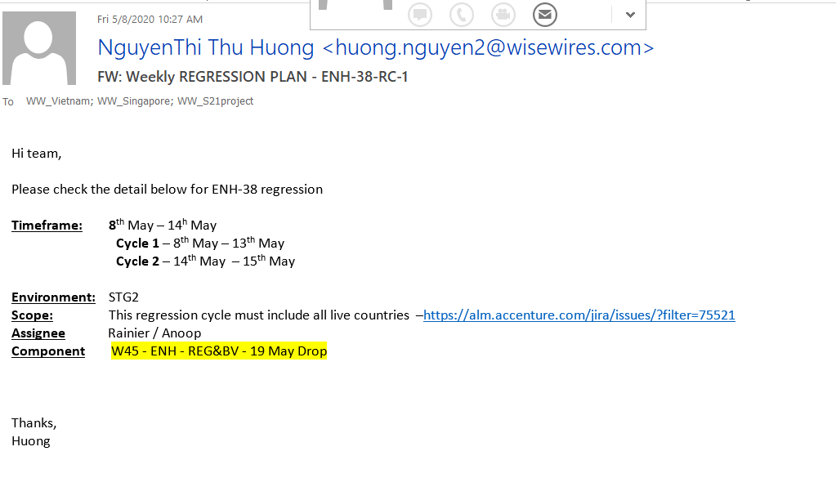

## 3.1.2. Maintenance regression test

- **Time**: Check in wiki

<https://wiki.shop.samsung.com/display/HM/Maintenance+Release+ENH-62-RC-2>

(AI team - SMI,SMN 1-> 5, SMC, SMB,...)

<https://wiki.shop.samsung.com/pages/viewpage.action?pageId=105911065>

(SDS team - SMA,SMR,SMS)

If we have monthly regression test this week, then no need maintenance regression test

**-Scope of testing:**

+ Choose 1 main site (Estore, EPP, Bulk order,..)

+ Choose test case of main business flows of selected main site: Log in, PLP, PDP, AEM Integration, Order placement,…

+ For the rest site: Test normal order flow of all payment methods

+ Test current ENHs/ maintenance tickets in the filter provided by AI/SDS team.

**-Link test suite:**

<https://docs.google.com/spreadsheets/d/17QTyWiOKgnUlUwQsZ1VanxKufaeVX6kza-XbC0SWQHc/edit#gid=105657614>

**- Announcement email example:**

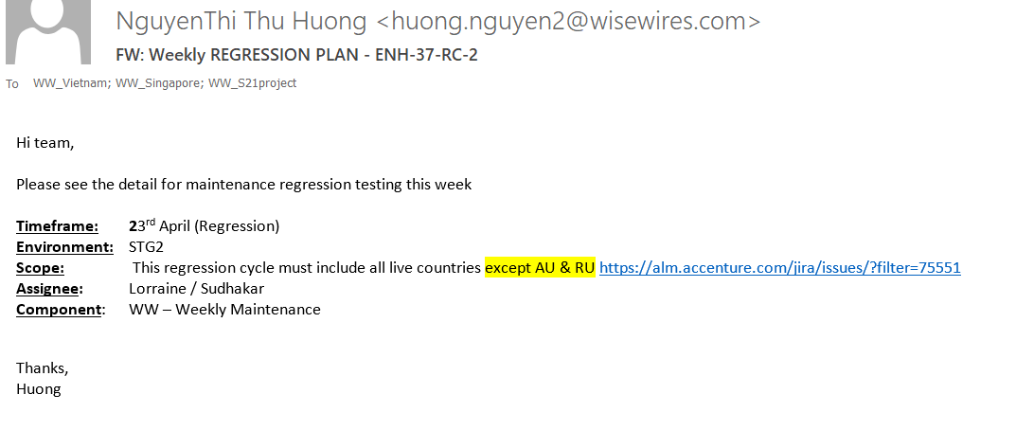

# 3.2. Test implementation

- Create test cases, include:

• Analyze business process

• Analyze use cases, design, requirements, test plan

• Identify test cases: test precondition, scenario, expected result

• Identify test case data

- Identify and structure test procedures, include:

• Analyze test cases

• Identify test procedures

• Structure test procedures: identify relationship and performing sequence of test procedures, starting and ending conditions, relation of test procedures and test cases

* Review test cases.

**For monthly regression test,** we create common testcases for GLOBAL ENHs in order to save team’s time and effort. Detail process is described below:

1. Regression lead scans the wiki to categorize the tickets by GLOBAL/country specific labels
2. Global ENHs test cases are prepared in Global ENHs TCs sheet.

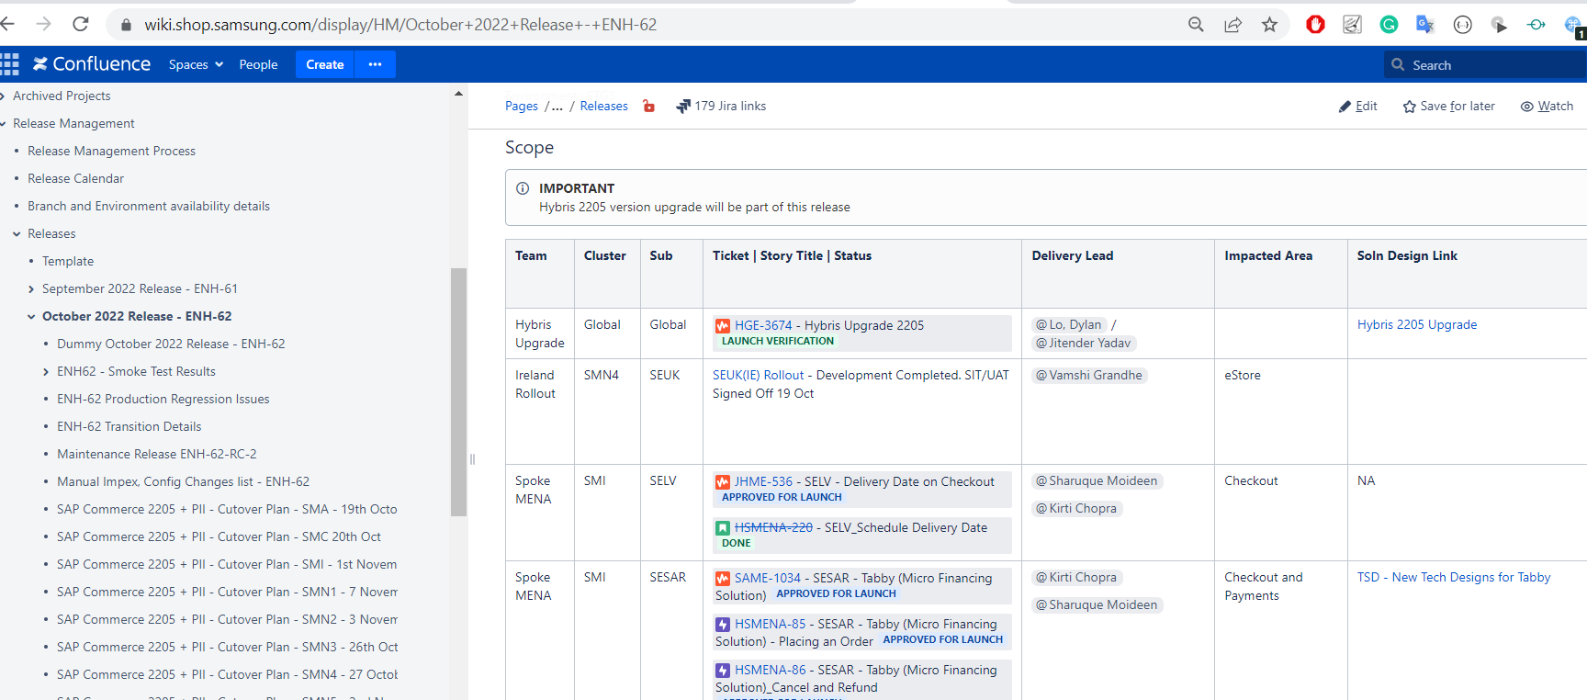

Link:

<https://docs.google.com/spreadsheets/d/1AlH23iPvmsPGOg6jPl2bzOFkUk_5F9VKz3dEe4ptw9o/edit#gid=0>

1. A meeting will be held if needed for all teams to share knowledge about how to test the complicated tickets.

5. By the 1st day of testing period, Regression lead sends email to all development teams to finalize the scope of testing. For any tickets whose status changed to QA SERVER REVIEW during testing period, WW will pick the Tickets to test base on its’ priority and resource. The rest will still be tested by their internal QA team.

# 3.3 Test execution

## 3.3.1. Execute testing

Conducts test based on test cases, record actual data regarding to test environment, test data, test activities and results

## 3.3.2. Scope change approach

Scope

* Delayed stories need to be communicated **before the code freeze date**, WW team and development team to make a decision on testing approach for any delayed stories. (details below)
* Deferred stories need to be communicated **before Regression test phase ends**. WW team and development team to make a decision on testing approach for any deferred stories. (details below)
* Stories deployed dormant need to be communicated **before Regression test phase ends**. WW team and development team to make a decision on testing approach for any deferred stories. (details below)
* Urgent Change requests need to be added to the scope page as well and directly communicated to WW team, regression team and release management team. Discussion needs to happen to discuss testing approach. (details below)
* Any Priority/Global hotfix/bug fix changes. Also need to be included in the scope page so that WW is aware and can validate it.

**Delayed Stories**

A delayed story is a story that still in development after code freeze date. In the case where a story is Delayed:

1. Development team to inform WW, Regression and release management team, via email with the estimates on time for completion and impact of functionality.
2. Development team to update the scope page and ticket with the proper details and new estimates.
3. Development team to update STG2 environment. (PRs and data/configurations as required)
4. If required, WW team and regression team to agree on an appropriate amount of testing for the delayed functionality. Points for consideration:
   1. Time left before regression phase ends/deployment to production
   2. Complexity of the delayed functionality
   3. Impact on regression of story vs other countries/clusters
5. WW to test functionality and provide report.

**Deferred Stories**

A deferred story is a story that is moved to a future release. In the case where a story is Deferred after regression starts.

1. Development team to inform WW, Regression and release management team, via email with the subsidiary/GMC communications.
2. Development team to update the scope page and ticket with the proper details and new estimates.
3. Development team to update STG2 environment. (revert PRs and data/configurations as required)
4. If required, WW team and regression team to agree on an appropriate amount of testing for the deferred functionality.
   1. Time left before regression phase ends/deployment to production
   2. Impact on regression of story and other countries/clusters
5. WW to test functionality and provide report.

**Dormant Stories**

A dormant story is a story that will go into production as a disabled functionality. In the case where a story is to be deployed Dormant, Team needs to be informed before the end of regression.

1. Development team to inform WW, Regression and release management team, via email with the subsidiary/GMC communications.
2. Development team to update the scope page and ticket with the proper details.
3. Development team to update STG2 environment. (Update data/configurations as required)
4. If required, WW team and regression team to agree on an appropriate amount of testing for the dormant functionality. With consideration to:
   1. Time left before regression phase ends/deployment to production
   2. Complexity of the dormant functionality
   3. Impact of regression of story vs other countries/clusters
   4. Dormant functionality turned off and on.
5. WW to test functionality and provide report.

**Urgent Change Requests**

A Urgent Change Request is a story that was not originally part of the scope, but has been added in due to extenuating circumstances. In the case where a Urgent Change Request is given:

1. Development team to inform WW, Regression and release management team, via email with the estimates on time for completion and impact of functionality as well as the subsidiary/GMC communications.
2. Development team to update the scope page and ticket with the proper details and estimates.
3. Development team to update STG2 environment. (PRs and data/configurations as required)
4. If required, Development, WW team and regression team to agree on an appropriate amount of testing for the change request functionality.
   1. Time left before regression phase ends/deployment to production
   2. Complexity of the functionality
   3. Impact of regression of story vs other countries/clusters
   4. Urgency of the request
5. WW to test functionality and provide report.

## 3.3.3. Log defect

- Log regression defects to Samsung Jira following template.

| Field | How to fill |
| --- | --- |
| Issue Type | Bug |
| Summary | Regression- Cluster- Env-Country code (Ex: SME/SAM-STG2/STG-REG-NO/SE)  Regression - SMS - STG2 - MY: Can not receive Partner O2O Sales Report |
| Defect Priority | Blocker/Critical/Medium/Low |
| Assignee | AI: the rest clusters  SDS: SMA/SMR/SMS |
| Component | Follow each Regression announcement |
| Description | * **Description- Sample:**   [Precondition]  N/A  [Steps to reproduce]   * 1.Login to the SME STG Base store of DE * 2.Click on any categories on Shop menu * 3.Navigate to PLP * 4. Select one specific category   [Actual results]   * Nothing change on PLP * Refer to: (image)   [Expected results]   * PLP should be displayed according to category user are selecting.   [Deployment version]  *From MS team notification (Ex:* **ENH.38.14)** |
| Environment | Link test |
| Labels | Follow rule defined in  <https://wisewiresglobal.atlassian.net/wiki/spaces/WG/pages/3671424/Regression+Defect+log+rule> |
| Attachment |  |

**Defect example:**

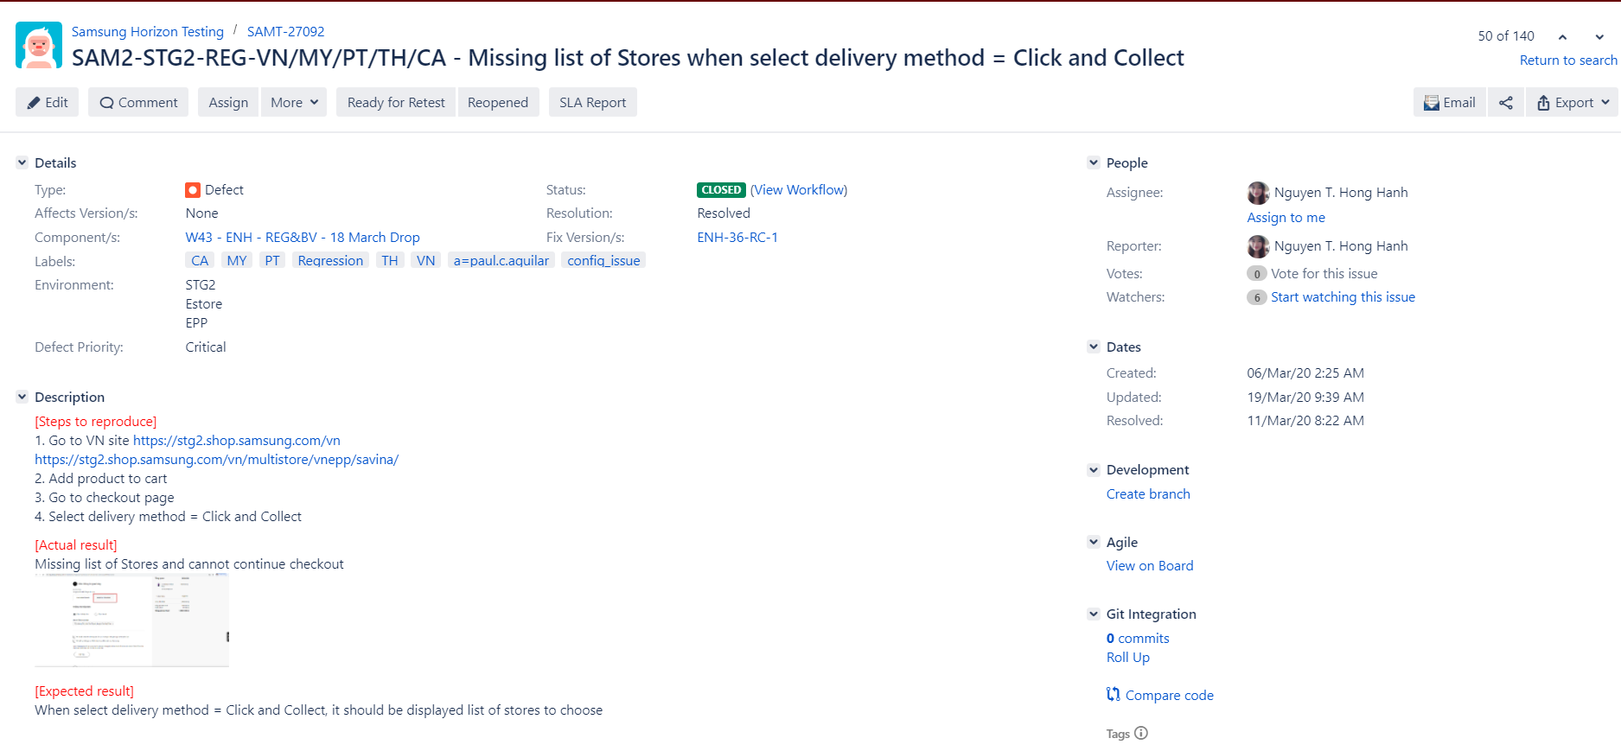

- Log ENHs defects to Samsung Jira following template.

| Field | How to fill |
| --- | --- |
| Issue Type | Bug |
| Summary | ENH ticket- Cluster-Env-Country code (Ex: SME/SAM-STG2/STG-REG-NO/SE)  THAME-2203 - SMS - STG2 -TH: Unable to receive Reminder email/ Expired payment email for 123 Bank Direct payment |
| Defect Priority | Blocker/Critical/Medium/Low |
| Assignee | Follow Defect assignee column to assign correct PIC of each Dev team  <https://wisewiresglobal.atlassian.net/wiki/spaces/WG/pages/3671424/Regression+Defect+log+rule> |
| Component | Follow each Regression announcement |
| Description | * **Description- Sample:**   [Precondition]  N/A  [Actual results]   * Nothing change on PLP * Refer to: (image)   [Expected results]   * PLP should be displayed according to category user are selecting.   [Steps to reproduce]   * 1.Login to the SME STG Base store of DE * 2.Click on any categories on Shop menu * 3.Navigate to PLP * 4. Select one specific category   [Deployment version]  *From MS team notification (Ex:* **ENH.38.14)** |
| Environment | Link test |
| Labels | Follow rule defined in  <https://wisewiresglobal.atlassian.net/wiki/spaces/WG/pages/3671424/Regression+Defect+log+rule>  Add 04= labels to define Dev teams. |
| Attachment |  |
|  | Link to main ENH ticket ( is tested for) |

Mark test result to test suite: Pass/Fail/Blocked

+ Pass

+ Fail: Need to have Jira defect ID in Defect number column

+ Blocked: MUST have **reasonable** reason to show why it’s not available to test

# 3.4 Defect management

## 3.4.1. General

-Defect should include all key information like URL, Page name, Order ID, SKU, User ID, Cart ID, Promotion Name, **Kibana Log**.

Also we can check issue by repeating the steps at least once more and providing the frequency of happening to understand the priority of defect in better way.

-Check the configurations (wherever applicable like CMS, Payment, Delivery modes) and test data before kicking off the test execution. This will help everyone saving lots of time and not focusing on config / data issue. Few config issues like impex’s, GERP config issue will still be fixed by AI Dev/DevOps team.

- Test only 'Ready for Retest' tickets

- Check on a daily basis to follow up on any of 'open ticket' assigned to WW (e.g. to provide further information for developers, to clarify any clues(screenshots, url, test env. test steps to reproduce) on the issues, etc.) After updating the comment or taking proper action to them, WW to assign back to AI team same person(who requested further actions and assign the ticket to WW)

Jira filter: <https://jira.shop.samsung.com:8443/secure/Dashboard.jspa?selectPageId=16101>

- WW to monitor open tickets to leave a comment to remind AI of issue follow-up ASAP (Prashant highlighted it to push AI developers to fix permanently some Config. related issues on AI side)

**- If original ticket is fixed, but another issue happens => Close old ticket, Create new ticket for new issue.**

- Put more focus on content of the defect which includes Title, description, Order ID, SKU, URL, Priority,…

## 3.4.2. Rules for tracking WW defect happened in multiple countries

When your country also faces this issue:

1. Add country code (2 characters: like IT,ES,..) and clustername (ex: SMI, SMN,..) to SUMMARY and LABELS fields. Add comment

2. Once the status is changed to "Ready for Retest"

(1) Read the comments first

(2) Test out the respective fixed countries

(3) If fixed, **Remove the country code in SUMMARY, keep the one in LABELS**

If the some countries still not fixed, reopen the ticket.

## 3.4.3. Duplicated rule.

<https://jira.shop.samsung.com:8443/issues/?filter=24615>

* Use basic filter
  + Project: RT
  + Issue type: Defect,Bug
  + Put 1 word or synonym of that word in the textbox

**For example:**

Your defect is about: Stock alert pop up is not working properly.

You can put “Stock alert” in the text search field

* + Scan all tickets found.
  + If ticket’s status is in Open, copy that ticket to our test result, add country code in Summary/Label
  + If ticket’s status is in Closed, Reopen that ticket
  + If no duplicate ticket found, Create new ticket

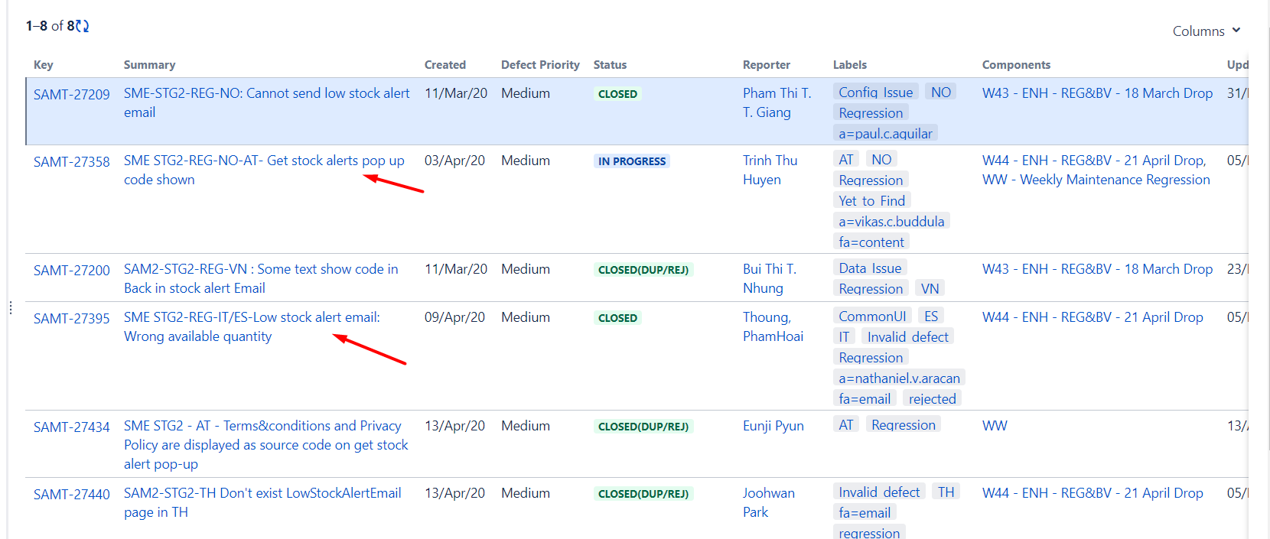

## 3.4.4. Reject rule

AI will **reject the tickets if no code change needed**.

o As Code release does not impact the PROD contents as all of you know, no need to worry about the content itself on STG if it is configurable therefore

o For any translation issue, we need to check firstly whether it is configurable(CMSable) or not o if possible to config by CMS cockpit, we dont have to raise a ticket, but any Translation missing part which is not a part of configuration, we need to log.

o For some areas in the webpage or any content, hard to know whether it is CMSable or not => any testers who needs help to understand, plz communicate with your regression lead or others before logging a ticket to prevent Rejection.

# 3.5. Defect analysis and Lesson learnt.

- After each regression testing, we need to analyze our data, have lesson learnt discussion in order to build our knowledge as well as improve our testing skills

- Regression lead collects data sent by each teams to file

**CONFIGURATION ISSUE**

<https://docs.google.com/spreadsheets/d/1vB--Hf80HoeBKyioUiljQjnZLaZ91lKy-GscLhJYv0g/edit#gid=0>

**HYBRIS KNOWLEDGE**

<https://docs.google.com/spreadsheets/d/1vB--Hf80HoeBKyioUiljQjnZLaZ91lKy-GscLhJYv0g/edit#gid=1929867393>

* **Update core test suite with the changes from the new ENHs. For any PROD issue, WW will analyze the impacts and add to main test suite if needed.**
* Knowledge sharing will be held monthly or quarterly to improve tester’s skill and both systems and countries requirement.